**Exercise 1: Implementing the Singleton Pattern**

**Code:**

class logger{

    private static logger instance;

    private logger() {

        // private constructor to prevent instantiation

    }

    public static logger getInstance() {

        if (instance == null) {

            instance = new logger();

        }

        return instance;

    }

    public void log(String message) {

        System.out.println("Log: " + message);

    }

}

public class SingletonPatternExample {

    public static void main(String[] args){

        logger log1 = logger.getInstance();

        logger log2 = logger.getInstance();

        log1.log("This is a singleton pattern example.");

        log2.log("Both log1 and log2 are the same instance: " + (log1 == log2));

    }

}

**Output :**

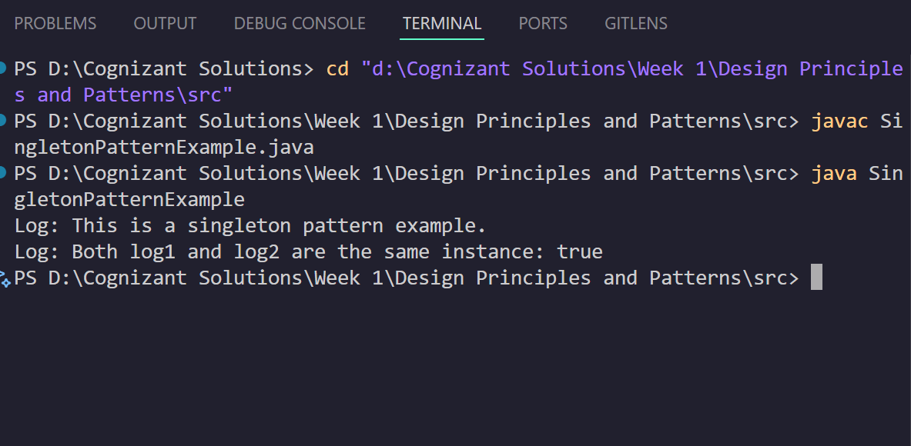

**Exercise 2: Implementing the FactoryMethod Pattern**

**Code:**

import java.util.Scanner;

interface WordDocument {

    void create();

}

interface PdfDocument {

    void create();

}

interface excelDocument {

    void create();

}

class WordDocumentImpl implements WordDocument {

    @Override

    public void create() {

        System.out.println("Word Document Created");

    }

}

class PdfDocumentImpl implements PdfDocument {

    @Override

    public void create() {

        System.out.println("PDF Document Created");

    }

}

class ExcelDocumentImpl implements excelDocument {

    @Override

    public void create() {

        System.out.println("Excel Document Created");

    }

}

abstract class DocumentFactory{

    abstract void createDocument();

}

class WordDocumentFactory extends DocumentFactory {

    @Override

    void createDocument() {

        WordDocument wordDoc = new WordDocumentImpl();

        wordDoc.create();

    }

}

class PdfDocumentFactory extends DocumentFactory {

    @Override

    void createDocument() {

        PdfDocument pdfDoc = new PdfDocumentImpl();

        pdfDoc.create();

    }

}

class ExcelDocumentFactory extends DocumentFactory {

    @Override

    void createDocument() {

        excelDocument excelDoc = new ExcelDocumentImpl();

        excelDoc.create();

    }

}

public class FactoryMethodPatternExample {

    public static void main(String[] args) {

        Scanner scanner = new Scanner(System.in);

        System.out.println("Enter the type of document to create (Word/PDF/Excel): ");

        String documentType = scanner.nextLine().trim().toLowerCase();

        scanner.close();

        DocumentFactory factory;

        factory = switch (documentType) {

            case "word" -> new WordDocumentFactory();

            case "pdf" -> new PdfDocumentFactory();

            case "excel" -> new ExcelDocumentFactory();

            default -> {

                System.out.println("Invalid document type.");

                yield null;

            }

        };

        if (factory != null) {

            factory.createDocument();

        }

    }

}

**Output:**

